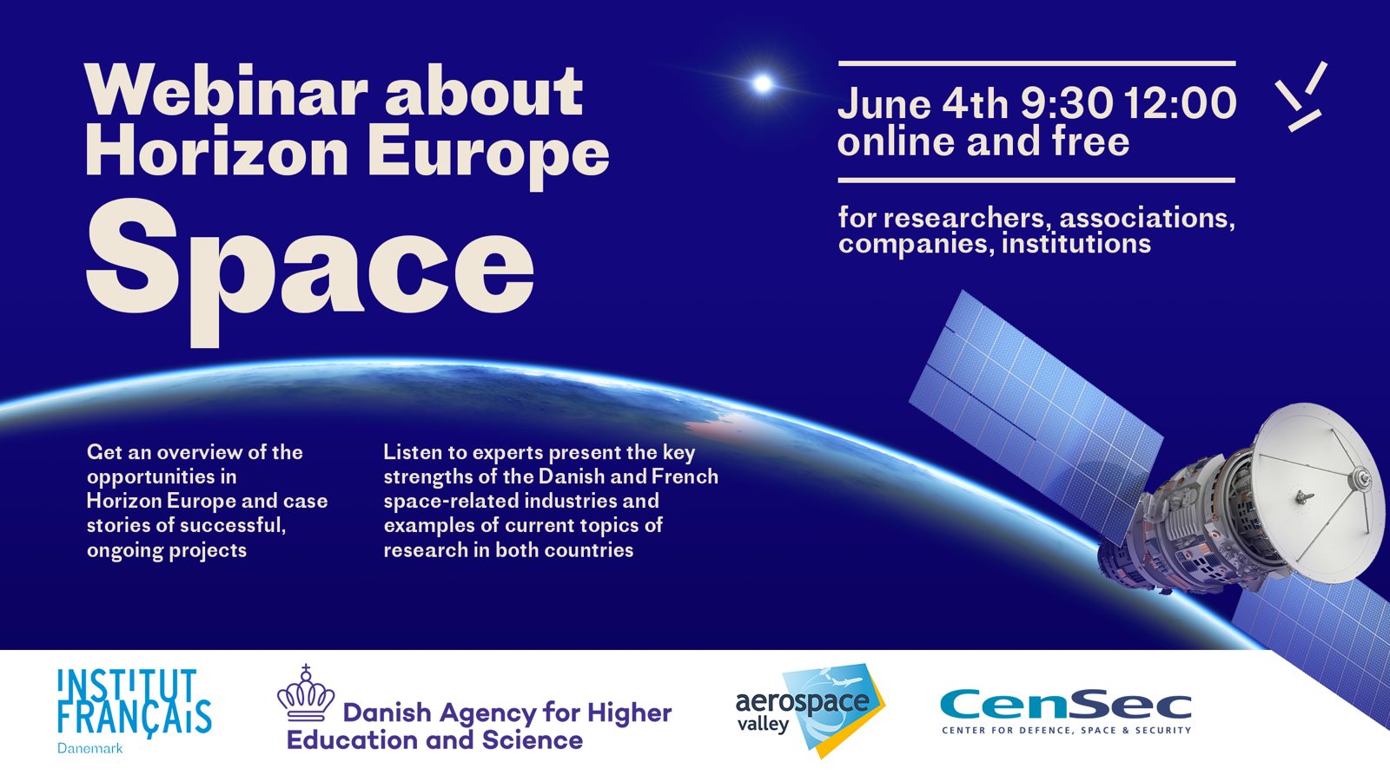

Are you a researcher, company or institution working in the field of space? Would you like to know more about R&I-opportunities in Horizon Europe? And would you like to learn more about potential partners in France or in Denmark? Then join us online on June 4th, 9:30-12:00!
The French Institute in Denmark and the Danish Agency for Higher Education and Science are organizing this online event on Danish-French R&I-collaboration on space and the new funding opportunities offered by the Horizon Europe programme (with an emphasis on Pillar II, Cluster 4, Destination 5 – ”Strategic autonomy in developing, deploying and using global space-based infrastructures, services, applications and data” : total funding of 300M€ for 2021-2022).
The aim is to develop technologies ensuring Europe’s access to space and to strengthen our use of European satellite data – and at the same time create jobs and support the green transition!
You will have the opportunity to listen to experts presenting the key strengths of the Danish and French space-related industries and hear examples of current R&I-topics, including two case stories of successful projects in Horizon 2020.
Sign up here: https://www.eventbrite.fr/e/danish-french-webinar-about-horizon-europe-space-registration-150980451595
This free event will be held in English.
Program :

- Space-related opportunities in Horizon Europe
Cecilie Tornøe, Special Adviser, Ministry of Higher Education and Science,
Danish Agency for Higher Education and Science,
National Contact Point for Space

French National Contact Point

- Two case stories of successful, ongoing projects
- I3DS project (Integrated 3D Sensors suite)
Vincent Dubanchet, Ph.D., R&D engineer in GNC & Space Robotics
Thales Alenia Space France (coordinator)

Uta Schneider, European Affairs, Manager - Public Affairs, Head of Brussels office,
TERMA Group (DK)

- The KEPLER project
Keld Qvistgaard, Senior Ice Advisor, Greenland Ice Service
Danish Meteorological Institute

Gilles Garric, Head of Innovation Team
Mercator Ocean International (FR)

- Presentation of the Danish space industry
Anders Laustsen, Project Development Manager
CENSEC (Danish cluster for small and medium-sized enterprises specializing in high tech industries like defence, homeland security, space, aerospace, railway and maritime)

- Presentation of the French space industry
Philippe Lattes, Deputy Director for Space
Aerospace Valley, Competitiveness Cluster for Aeronautics, Space, Drones and Embedded System (FR)

- Examples of research topics at DTU Space (DK)
Michael Linden-Vørnle, Astrophysicist (PhD) and Chief Adviser
DTU Space - National Space Institute

- Examples of research topics at CNRS (FR)
Anny Cazenave, Research scientist at LEGOS/CNES (Laboratory for Studies in Geophysics and Space Oceanography
Director for Earth sciences at ISSI (International Space Science Institute), Bern, Switzerland
President, Geodesy Section, AGU (American Geophysical Union)

- Questions and answers

#space #horizoneurope #brugrummet
Link to event website:https://institutfrancais.dk/da/arrangementer/horizon-europe-dansk-fransk-webinar-om-space

